Web Development (Introduction)
  WEB DEVELOPMENT (WEDE5020) POE PROJECT PROPOSAL 2 | Lehlohonolo Mahase  St10447181

Contents
Proposal 2: Amicon Cycles – A Retail Bicycle Store in Secunda, Mpumalanga. 2
Organizational Overview 2
Mission and Vision: 2
Website Goals and Objectives 2
Goals: 2
KPIs: 2
Current Website Analysis 3
Strengths 3
Weakness: 3
Areas for Improvement 3
Proposed Website Features and Functionality 3
Pages: 3
Functionality: 3
Design and User Experience 4
Color Scheme: 4
Typography: 4
Layout and Design: 4
User Experience Considerations: 4
Technical Requirements 4
Timeline and Milestones 4
Budget 5

Content research – Amicon Cycles
The Bicycle Market Overview in South Africa
The bicycle market in South Africa represents a huge and growing sector. According to (Research, 2026) in 2025 the market has generated revenue of $1.4B and is expected to reach $2.5B by the end of the decade. The market will grow at a compound annual growth rate of 7.4% from 2026 to 2030. The increase in demand across different segments is the reason for the significant growth, with road bikes being the product generating the largest revenue while cargo bikes are the fastest growing product in the market in South Africa (Research, 2026)
According to (Nextdigm, 2026), health, sustainable mobility, and fitness trends are the main reasons for the growth of the bicycle market in South Africa. (Nextdigm, 2026) states that with cycling becoming relevant for recreation, commuting, and fitness, the market is growing at a 5.9% compound annual growth rate. Health awareness, rising fuel costs and interest in sustainable transportation are supporting the long-term demand, making bicycles useful for practical everyday movement.
E-Commerce and Online Sales in The South African Bicycle Industry
Bicycles and accessories are gaining traction on online sales in the South African market. (Payflex, 2024) states that 13 leading cycling shops are developing a loyal following, noting that many cyclists prefer the community aspect of a brick-layer-and mortar store.
South Africa’s leading online marketplace for bicycles, Bike Hub, processed R273.5 million in sales in the year 2025, increasing by 9.8% year-over-year. This demonstrates that consumers in South Africa are increasingly comfortable buying bicycles and related products online (Hub, 2026).

Proposal 2: Amicon Cycles – A Retail Bicycle Store in Secunda, Mpumalanga.

Organizational Overview
Name: Amicon Cycles
History: Amicon Cycles is a bicycle retail store that was founded in 2017 by Jaco Visser, who is passionate about cycling and is also an experienced mechanic. The store is in Secunda, Mpumalanga. It began as a small repair shop for servicing bicycles for residents and mine workers and over time it grew into retail, offering a wide variety of bicycles, maintenance services, and accessories.

Mission and Vision:
- Mission: The mission statement is to promote cycling as a healthy lifestyle in the Secunda region by offering quality bicycles, expert repair services at affordable prices, and accessories.
- Vision: To become the premier bicycle retail destination in Mpumalanga by connecting cyclists of all levels and fostering a vibrant cycling community.
Target Audience: Residents in Secunda (fitness enthusiasts, commuters, local cyclists and sports clubs, families, etc.)

Website Goals and Objectives

Goals:
- To build community by providing valuable cycling information.
- Increase brand awareness by showcasing the product catalogue online.
- Generating leads through service bookings and online enquiries.
- To increase foot traffic to the physical store

KPIs:
- Increase the traffic on the website by 25% within the first 3 months after launch.
- To have 15 service bookings per month that are generated through the website.
- To reach 150 visitors in store for the first 6 months after launch.

Current Website Analysis
Strengths: The store currently does not have an existing website, but it has a strong local reputation through community events and word-of-mouth.
Weakness: The store is missing out on opportunities to attract new customers due to not having any web presence, it cannot show the products to the customers before they visit the store resulting in losing potential sales to competitors online, Research states that bicycle shops that work independently often time operate as low-margin businesses, the businesses make more profit by making custom bikes, repairs and accessories rather than selling bikes. Having a website would significantly help in capturing this additional revenue stream.
Areas for Improvement: A website would allow customers to browse products, serve as a 24/7 showcase and establish credibility for the store. This approach corresponds with research that shows that e-commerce websites are crucial to use in small business processes to make transactions efficient and effective.

Proposed Website Features and Functionality

Pages:
- Homepage: A welcoming banner with the featured products, the reviews from customers, and services that offered. According to CycleBay, a call-to-action button helps guide user attention through natural sight patterns.
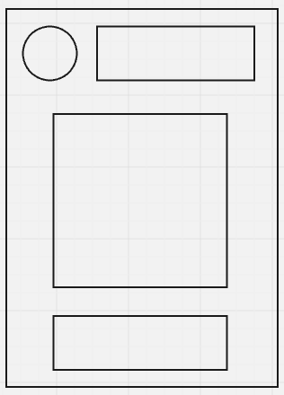
- About us: Store history, mission, vision, team members, and core values.
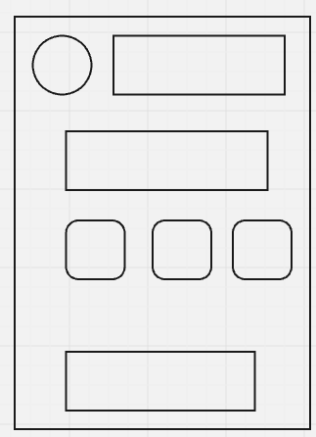
- Services/Products: Categories of the products, prices and high-quality images.
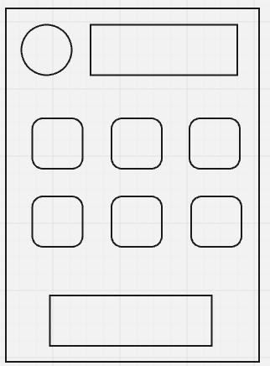
- Enquiry: Service and product enquiry form.
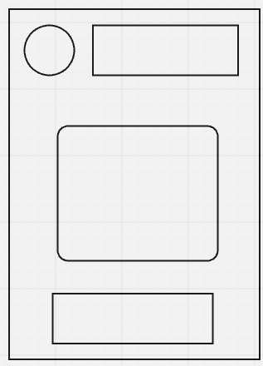

- Contact: Location, operating hours, email, phone number, and Google maps integration.
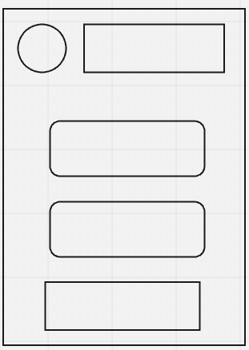
- Sitemap: The visual structure of the websites
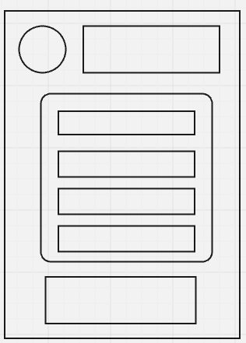

Sitemap
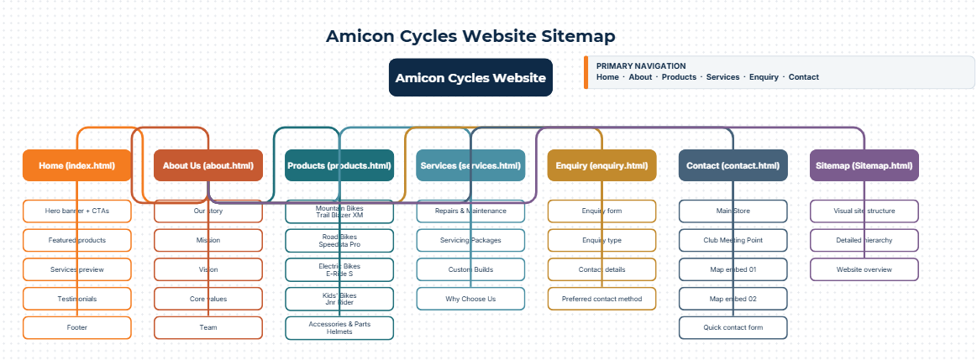

Functionality:
- Product browsing with categories.
- Online enquiry form that sends email notification automatically.
- Google maps integration for the store location.
- WhatsApp integration for instant communication.

Design and User Experience

Color Scheme:
- Main: Grey and white.
- Secondary: Blue and Orange

Typography:
- Heading: Bold, strong.
- Body text: Open Sans
Layout and Design: The design will reflect the active cycling lifestyle with emphasized dynamism and energy including high-quality images that will be central to the experience of the user. The products will be shown clearly with intuitive navigation that enables customers to find what they need quickly. According to Noushan, UI and UX designs that display clean accessible layouts are important for user satisfaction. Wireframes that are low fidelity will be developed to showcase the website’s layout and information before the development begins.

User Experience Considerations:
- Mobile-first responsive design
- Call-to-action buttons that are clear for enquiries and ordering.

Technical Requirements
- Hosting: South Africa-based hosting for quick loading times
- Domain: www.amiconcycles.co.za
- Programming Languages: HTML, CSS, and JavaScript.
- Database: MySQL for enquiry management and product catalogue.

Timeline and Milestones
Milestone | Duration | Description
Part 1: Building the foundation | Week 1-3 | Gathering content, brief designs and creating design mockups.
Part 2: Designing the Visuals | Week 4-6 | Building the website and quality photography of store products.
Part 3: Adding functionality and SEO | Week 7-10 | Enhance the website with interactive features and optimize it for search engines.

Budget
Item | Estimated Cost
Registration (Domain) – 1 yr | R200 – R250
Web Hosting – 1 yr | R 2,000 – R 3,500
Website Design and Development | R 7,500 – R13,000
Maintenance (annually) | R 4,500 – R 6,000
Total Estimated Budget | R 14,200 – R 22,750

Bibliography
Adoption, S. A. B. M. O. B. b. $. M. D. a. R. E.-B., 2026. Nextdigm. [Online]
Available at: https://www.nexdigm.com/market-research/insights/blog/south-africa-bicycle-industry/
[Accessed 13 September 2026].
Hub, B., 2026. Quater Turn Report: Bike Hub Q1. [Online]
Available at: https://bikehub.co.za/news/quarter-turn-report-bike-hub-q1-2026/
[Accessed 13 September 2026].
Lab, C., 2026. Buy Mountain Bikes /Road Bikes/ Best Bicycle Shop Online.. [Online]
Available at: https://www.cyclelab.com/
[Accessed 13 September 2026].
Nextdigm, 2026. South Africa Bicycle. [Online]
Available at: https://www.nexdigm.com/market-research/insights/blog/south-africa-bicycle-industry/
[Accessed 13 September 2026].
Nextdigm, 2026. South Africa Bicycle Market Outlook Backed by $471.80 Million Demand and Rising E-Bike Adoption. [Online]
Available at: https://www.nexdigm.com/market-research/insights/blog/south-africa-bicycle-industry/
[Accessed 13 September 2026].
Outlook, S. A. B. M. S. &., 2026. Grand View Research. [Online]
Available at: https://www.grandviewresearch.com/horizon/outlook/bicycle-market/south-africa
[Accessed 13 September 2026].
Payflex, 2024. A Guide to South Africa's Online Cycling Shops.. [Online]
Available at: https://payflex.co.za/a-guide-to-south-africas-online-cycling-shops-payflex/
[Accessed 13 September 2024].
Research, G. V., 2026. South Africa Bicycle Market Size and Outlook. [Online]
Available at: https://www.grandviewresearch.com/horizon/outlook/bicycle-market/south-africa
[Accessed 13 September 2026].

BikeStore. (2025). Full-Featured Bike Shop Application [Source code]. Available at: https://github.com/SM-Noushan/bike-store-client (Accessed: 14 August 2026).
CycleBay. (2025). Bike Shop - Business to Customer (B2C) E-commerce Full Stack Django-based Web Application [Source code]. Available at: https://github.com/pavlo-myskov/cyclebay (Accessed: 14 August 2026).
CycleZen: A Digital Transformation in Bicycle Retail Management. (2025). Daffodil International University. Available at: http://dspace.daffodilvarsity.edu.bd:8080/handle/123456789/16992 (Accessed: 14 August 2026).
E-commerce Website Development for KawanKita Bicycle Shop. (2023). Garuda - Garba Rujukan Digital. Available at: https://garuda.kemdiktisaintek.go.id/documents/detail/3669513 (Accessed: 14 August 2026).
Jadav, A.D. (2003). Designing Usable Web Interfaces. Upper Saddle River, NJ: Prentice Hall.
The Multiple Perspectives Project Definition Method. (2001). Seventh Americas Conference on Information Systems.

